1. Use Selenium IDE to automate the login process for the Flipkart website, ensuring the test script waits for the home page to load after login.<br><br><em><strong>Hint:</strong> Use the 'wait for element' command to confirm the user dashboard or profile icon is visible after logging in.</em>
Ans=> 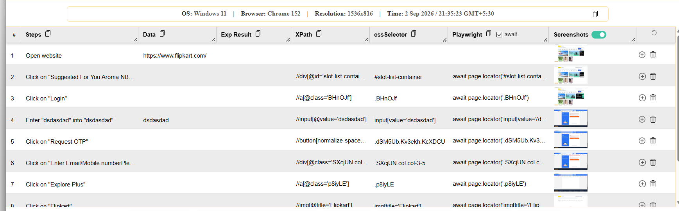

2. Record a Selenium IDE test that adds two products to the cart on Myntra, then verifies that both items appear in the cart summary.
Ans=> 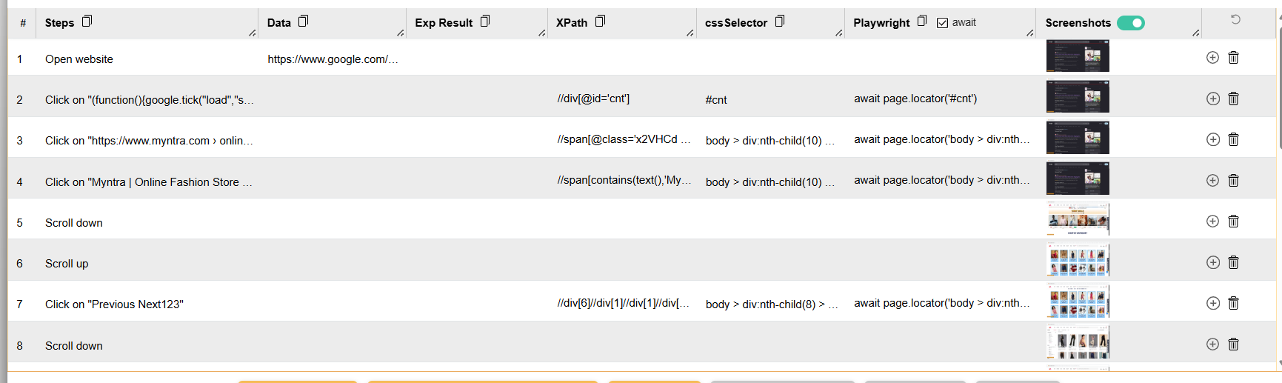

3. Create a Selenium IDE script to log out of your Zomato account after adding an item to the cart, and validate that the login page is displayed again.
Ans=> 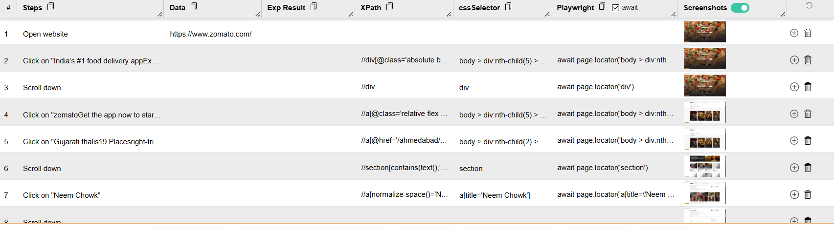

4. Export your Selenium IDE test suite as a test plan document, including steps for login, adding items, cart validation, and logout, and briefly describe the expected result for each step.
Ans=> Selenium IDE Test Plan — E-Commerce Workflow
Test Plan Details
Test Suite: E-Commerce Shopping Workflow
Tool: Selenium IDE
Test Type: Functional UI Automation
Objective: Verify that a user can log in, add products to the cart, validate the cart contents, and log out successfully.
Test Case 1: Login
Step | Action | Expected Result
1 | Open the e-commerce website | Homepage loads successfully
2 | Click Login/Sign In | Login page or login form is displayed
3 | Enter a valid username/email | Username/email is accepted
4 | Enter a valid password | Password is accepted
5 | Click Login | User is authenticated and redirected to the account/home page
Expected overall result: User successfully logs in and is shown as an authenticated user.
Test Case 2: Add Items to Cart
Step | Action | Expected Result
1 | Search for a product | Relevant search results are displayed
2 | Select a product | Product details page opens
3 | Click Add to Cart | Product is added to the cart
4 | Add another product | Second product is added successfully
5 | Open the cart | Cart page displays the selected products
Expected overall result: All selected products are present in the shopping cart.
Test Case 3: Cart Validation
Step | Action | Expected Result
1 | Open the shopping cart | Cart contents are displayed
2 | Verify product names | Expected products are listed
3 | Verify quantities | Quantities match the items added
4 | Verify item prices | Prices correspond to the selected products
5 | Verify total amount | Cart total is calculated correctly
Expected overall result: Cart contents, quantities, prices, and total are correct.
Test Case 4: Logout
Step | Action | Expected Result
1 | Open the account/user menu | Account options are displayed
2 | Click Logout/Sign Out | User session is terminated
3 | Verify the resulting page | Login/sign-in option is displayed
4 | Attempt to access an authenticated page, if applicable | User is redirected to login or denied access
Expected overall result: User is successfully logged out and authenticated-only functionality is no longer accessible.
Selenium IDE Suite Summary
Tests: 4
Workflow: Login → Add Items → Validate Cart → Logout
Expected Result: All test cases pass and the complete shopping workflow functions correctly.
Export Note
The Selenium IDE project can be exported in a supported format from Selenium IDE → Export. Keeping the exported test plan provides a portable record of the automated workflow that can be shared with QA engineers, reviewed, version-controlled, or adapted for another automation environment.

